**Initial motive :**

Given the core motive, let's outline a plan that emphasizes a smooth news aggregation experience combined with a valuable vocabulary learning tool.

**Prioritized Features :**

1. **News Aggregation :**
   * **Setup:** Flask project, install libraries, project structure .
   * **API Selection:**  We have Choose NewsAPI (for structured data and relative ease of use) over the Google Programmable Search Engine API or web scraping due to the need for structured articles for good word detection.
   * **Fetching:** We have created a fetch_news() function that can fetch *multiple articles* with pagination.
   * **Data Extraction:** Extract relevant data (title, description, URL, source).
   * **Basic Display:** Create a templates/news.html file to display the core news information on a webpage.
   * **Refrain from any category option if possible**
2. **Vocabulary Enhancement :**
   * **Word Identification Strategy:** Choose to identify difficult words based on frequency in a known vocabulary.
     + This is easier and faster than trying to implement a more advanced NLP to determine if a word is difficult.
     + Use NLTK's built-in word list
   * **Integration:** Use Python lists, or functions, to make your page fast and responsive.
   * **Dictionary API Integration**: Use an external dictionary API to provide definitions of words on click
     + Use a dictionary API. The data should be read on the same page instead of redirecting
     + To accomplish this, use javascript on click function
     + Set your default to beginner.
   * **Vocabulary Difficulty Setting**: For the bare-bones minimal MVP
3. **Integration and UI :**
   * **Linking:** In the HTML, make it so the title brings to page in a new tab and in the HTML page each of the keys are clickable and will render data
   * **Styling:** Make it readable and not cluttered
   * Avoid making changes if possible

**Tech Choices :**

* **Backend:** Python (Flask)
* **News API:** NewsAPI
* **Vocabulary API:** Oxford Dictionary API
* **Word List:** NLTK Word List
* **Frontend:** Basic HTML,CSS and JS

**How is our solution different from the existing ones?**

**I. Enhanced Information Consumption & Learning:**

1. **Active Learning vs. Passive Reading:**
   * **Existing:** Primarily passive consumption. Users simply read the news.
   * **Our Solution:** Promotes active learning by prompting users to engage with new vocabulary. This makes the information more memorable and useful.
2. **Bridging the Knowledge Gap:**
   * **Existing:** Assumes users have a sufficient vocabulary to understand articles. Can be frustrating for non-native speakers or readers with limited vocabulary.
   * **Our Solution:** Directly addresses this knowledge gap by providing on-demand definitions. This makes news accessible to a wider audience.
3. **Learning Tailored to Current Events:**
   * **Existing:** Vocabulary learning often occurs in isolation or using generic textbooks.
   * **Our Solution:** Connects vocabulary learning directly to current events, making the learning more relevant and engaging.

**II. Customization and User Experience:**

1. **Focused Learning Experience:**
   * **Existing:** News aggregators often bombard users with a vast amount of information.
   * **Our Solution:** Provides a focused learning experience by allowing users to prioritize articles based on their learning goals.
2. **Integrated Tools and Features:**
   * **Existing:** Limited by having external links to other APIs, and having an external look and feel.
   * **Our Solution:** With external tools built into the web page creates a smooth seamless experience.

**III. Addressing Potential Drawbacks of Existing Solutions:**

1. **Combating Information Overload:**
   * **Existing:** Many news aggregators contribute to information overload, presenting users with an overwhelming number of articles.
   * **Our Solution:** If used carefully, the vocabulary enhancement could actually serve as a filter. Users might be more likely to focus on articles with relevant or interesting new words, reducing the overall information load. Also topic suggestions are highly specified so the user always finds a good starting point.

**Key Phrases to Articulate Your UVP:**

* "Our news aggregator helps you become a more informed *and* articulate citizen."
* "It's not just about reading the news; it's about understanding it and expanding your horizons."
* "We transform passive consumption into an active learning experience."
* "Our product has a simple page, a limited scope to increase page load times"
* "By setting your skill it adapts to you."

By emphasizing these points, you can effectively communicate the unique value of your project and how it stands out from the crowded field of news aggregators. Remember to test these points out as you start your project so the UI aligns with the product plan!

**UI SCREENS:**

**USING CLI:**

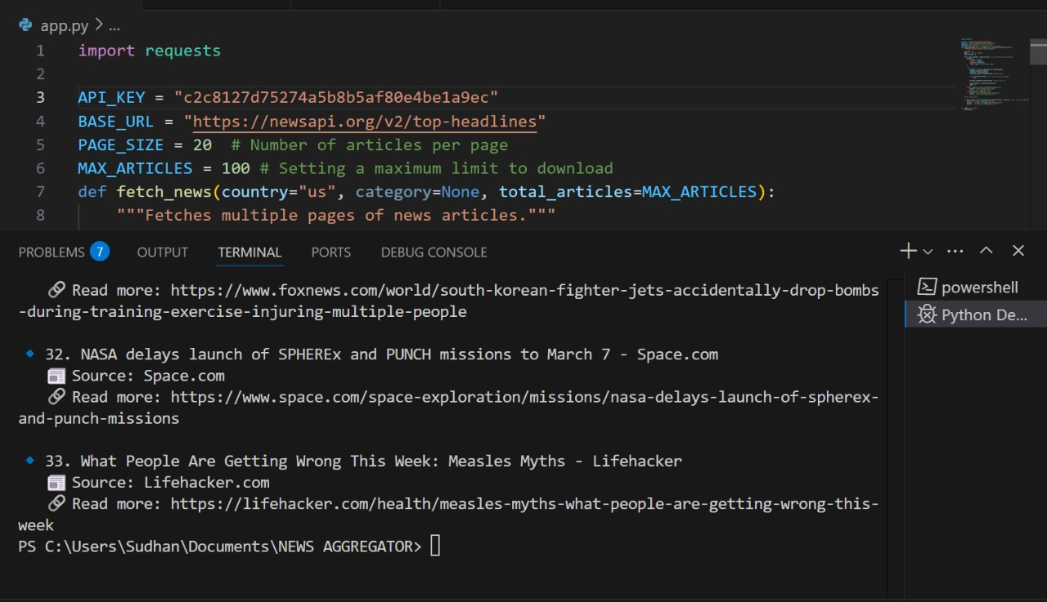

**USING NEWS API:**

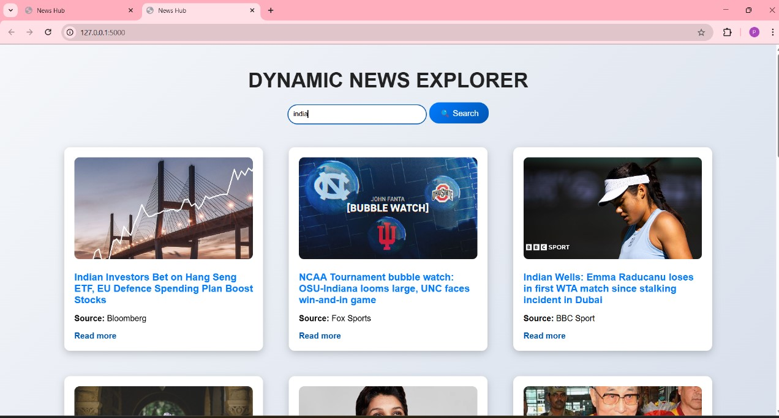

**USING WEB SCRAPING:**

